Percent (Mathisfun)

When we say "Percent" we are really saying "per 100"
One percent (1%) means 1 per 100.
xxxxxxxxxxxxxxxxxxxxxxxxxxxxxxxxxxxxxxxxxxxxxxxxxxxxxxxxxxxxxxxxxxxxxxxxxxxxxxxxxxxxxxxxxxxxxxxxxxxxxxxxxxxxxxxxxxxx
1% of this line is shaded green: it is very small isn't it?

50% means 50 per 100
(50% of this box is green)
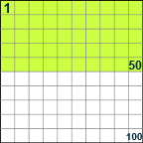
25% means 25 per 100
(25% of this box is green)
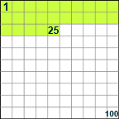

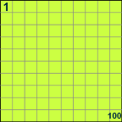 |  | 100% means all.  Example:  100% of 80 is 100/100 × 80 = 80
50% means half.
Example:
50% of 80 is 50/100 × 80 = 40

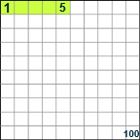 5% means ⁵/_{100ths}.
Example:
5% of 80 is 5/100 × 80 = 4

Divide the denominator (100) into the numerator to determine the decimal or percent. 50/100 = .50 = 50%

Divide the denominator (100) into the numerator to determine the decimal or percent. 75/100 = .75 = 75%

Percent | Decimal | Fraction
1% | 0.01 | ¹/₁₀₀
5% | 0.05 | ¹/₂₀
10% | 0.1 | ¹/₁₀
12½% | 0.125 | ¹/₈
20% | 0.2 | ¹/₅
25% | 0.25 | ¹/₄
33¹/₃% | 0.333... | ¹/₃
50% | 0.5 | ¹/₂
75% | 0.75 | ³/₄
80% | 0.8 | ⁴/₅
90% | 0.9 | ⁹/₁₀
99% | 0.99 | ⁹⁹/₁₀₀
100% | 1
125% | 1.25 | ⁵/₄
150% | 1.5 | ³/₂
200% | 2

75% of 60 = ?
75% = 75/100 = 0.75
So:
0.75 × 60 = 45
------------------------------------------------------------------------------------------------------
If 16 of 200 apples were bad, what percent is that?
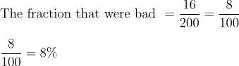
8/100 = .08 = 8%

_____________________________________________________
In a class of 25 students, 16 had at least one pet. What percent is that?

The fraction of the class that had at least one pet = 16/25

16 divided 25 is .64 or 64%

_________________________________________________________________________________

